Credit Reference Platform Gateway  
Patching Guide

V1.5

August 2024

# Change Log

|  |  |  |
| --- | --- | --- |
| Version | Author | Description |
| 1.0 | VH | Initial Release |
| 1.1 | Jim | Modify Applying the Patch |
| 1.2 | Jim | Add cert update |
| 1.3 | Jim | change cert update |
| 1.4 | Jim | add cert update fail handle case |
| 1.5 | Jim | Change update jar |

# Purpose

This guide covers the upgrades for the Credit Reference Platform Gateway (CRP Gateway) standalone web service. This standalone web service is the easiest installation for facilitate the functionalities on Credit Reference Platform (CRP) and suitable for developers/maintainers for development or production deployment.

# Version Lower than 1.4.0 à Version 1.4.x

### Unzip the CRP Gateway Artifacts Archive

Retrieve the package crp-gateway-<version>-archive.tar.gz  
Unzip the contents to obtain the JAR archive in path *cdtech/crp-gateway/crp-gateway-<version>.jar*

# ls  
crp-gateway-<version>-archive.tar.gz  
# tar -xzvf crp-gateway-<version>-archive.tar.gz  
# ls  
cdtech crp-gateway-<version>-archive.tar.gz   
# cd cdtech/crp-gateway  
# ls  
app-run.sh crp-gateway-<version>.jar

Inside the package includes the application standalone executable JAR and some necessary folders and scripts. For more information of the package remember to check the RELEASE-NOTES and CHANGELOG of your release.

### Applying the Patch

1. Stop the running service (if any)
2. Backup the old JAR archive (not need to backup app-run.sh)
3. Move the new JAR archive and app-run.sh into */opt/cdtech/crp-gateway*
4. Start the service

## Stop the Running Service

# cd /opt/cdtech/crp-gateway  
# sh app-run.sh **stop**

## Backup the old JAR Archive

# cd /opt/cdtech/crp-gateway  
# mkdir -p backup  
# ls  
... backup crp-gateway-<oldVersion>.jar ...  
# mv crp-gateway-<oldVersion>.jar backup/

## Move the new JAR archive into */opt/cdtech/crp-gateway* # mv <extractedPath>/cdtech/crp-gateway/crp-gateway-<version>.jar .

## Start the Service

# sh app-run.sh **start** *[JAVA_OPTS]*>>> JAR_NAME = ./crp-gateway-<version>.jar <<<  
>>> API_NAME = crp-gateway-<version> <<<  
Master Keystore Password:  
>>> start ./crp-gateway-<version>.jar successed PID=<PID> <<<

Remarks:  
The JAVA_OPTS is optional for the application and the following command is an example

# sh app-run.sh start -Dspring.profiles.active=scheduler -Dlogging.level.com.gitlab.credit_reference_platform=TRACE -Dfeign.client.config.default.loggerLevel=FULL

| Properties Key | Description |
| --- | --- |
| spring.profiles.active | The activated profile(s) to be configured during application start, multiple profiles are allowed with separated by comma(,)  Available options:   * scheduler * distributed |
| logging.level.<packageName> | The logging level for the Classes with package starting with <packageName>  Available values (from lowest):   * TRACE * DEBUG * INFO * WARN * ERROR |
| feign.client.config.default.loggerLevel | The logging details of the FeignClient when sending requests to CRP.  Available values:   * FULL |

# Health Check

Execute the following curl commands to know the CRP Gateway is running and accepting requests:

# curl –insecure https://<host>/actuator/health  
{“status”:”UP”,”components”:{…}}

The application status is specified is the beginning of the response, with statuses:

* UP: all the components are running
* DOWN: some components is not ready, i.e. database connection

# System Logs

The system logs is located under *${baseDir}/log*. The logs will be rotated by date, and the log filename of today would be *crp-gateway.log*

# Cert Update

First,Click Account Management and Add New Certificate

Renew Certificate

Click Encryption Certificate

*A Certificate and password* are purchased from **HK Post.**

**Please change to** *Certificate* and *Private Key*

These commands require a Linux system to work.

*Certificate*

**openssl pkcs12 -in <HKPostCertificate** **> -clcerts -nokeys -out crp-gateway.crt**

The password was also purchased from Hong Kong Post

*Private Key*

**openssl pkcs12 -in <HKPostCertificate** **> -nocerts -nodes | openssl rsa | openssl pkcs8 -topk8 -nocrypt -out crp-gateway.key**

**Please check the certificate first, you may need to remove the header**

Correct format

--*BEGIN CERTIFICATE*--

*MIIE5zCCA8*+*gAwIBAgIQN*+*whYc2BgzAogau0dc3PtzANBgkqh*......

--*END CERTIFICATE*--

Active the new Certificate and deactivate the old Certificate

Click File Management

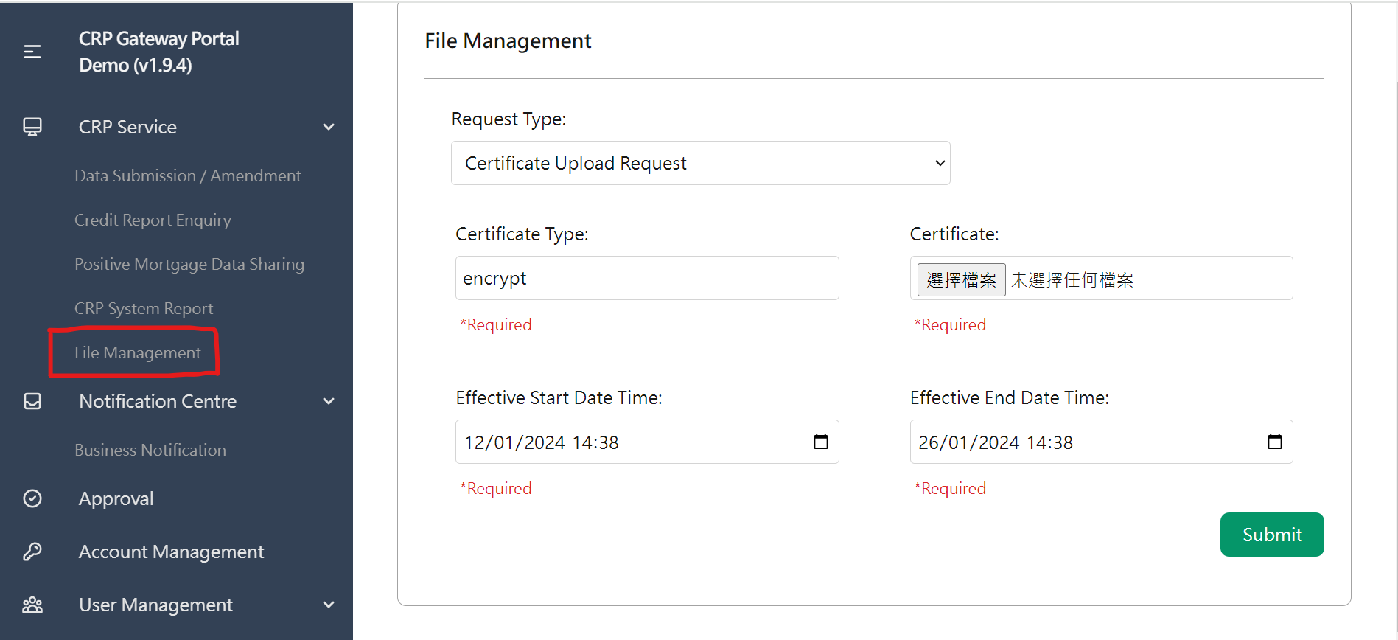

Request Type = Certificate Upload Request

Certificate Type = encrypt

Effective Start Date Time and end time can find in cert

Certificate start date need to later than Certificate start date set in Certificate(set more than 1 day)

Please enter 1 day more than the start date in the certificate in the Effective Start Date Time

Certificate is same with above Certificate **but require base64 encode in File Management**.

<https://base64.guru/converter/encode/file>

or use notedpad++

ctrl+a first and use Base64 encode then save

Submit and cap the result.

Restart the CRP Gateway

**If success code is returned, this submit method cannot be repeated.**

**For example, if you forget to remove the header in your certificate,**

**Submission still succeeds but fails in CRA,**

**If the server return fails, you can try again.** 

**If the certificate update fails(return success code but CRA said it is fails) , please fill out this form and email it to CRP**

**Form**

